Quiz 02 學號 姓名
- Consider the following Zener diode circuit
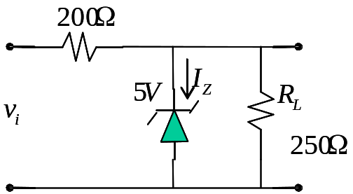

Let 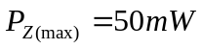 and 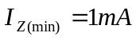,
- In the case of 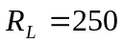, find the range of 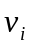 such that 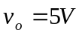.
- In the case of 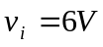, find the range of 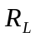 such that .
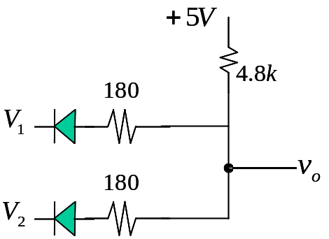
- For the following circuit, the diode has 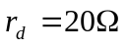, 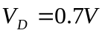. Find 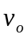 for the case of 